
Holy Cross College

Semester 1 Examination 2020

Answer Booklet

Please place your student identification label in this box
Year 10 Science
(Adjusted)

Student Name
Student’s Teacher

Time allowed for this paper

Reading time before commencing work: 5 minutes
Working time for paper: 60 minutes

Materials required/recommended for this paper

To be provided by the supervisor

This Question/Answer Booklet
Data Sheet

To be provided by the candidate

Standard items: pens, pencils, eraser, correction fluid, ruler, highlighters.
Special items: non-programmable calculators satisfying the conditions set by the School Curriculum and Standards Authority for this course.

Important note to candidates

No other items may be taken into the examination room. It is your responsibility to ensure that you do not have any unauthorised notes or other items of a non-personal nature in the examination room. If you have any unauthorised material with you, hand it to the supervisor before reading any further.

Structure of this paper

Section | Number of questions available | Number of questions to be answered | Suggested working time  (minutes) | Marks available | Percentage of exam
Section One:  Multiple Choice | 30 | 30 | 30 | 30 | 45
Section Two:  Short Answer | 6 | 6 | 30 | 47 | 55
Section Three:  Comprehension | - | - | - | - | -
 |  |  |  | 77 | 100

Instructions to candidates

1. The rules for the conduct of examinations at Holy Cross College are detailed in the College Examination Policy. Sitting this examination implies that you agree to abide by these rules.

2. Write your answers in this Question/Answer Booklet.

3. Working or reasoning should be clearly shown when calculating or estimating answers.

4. You must be careful to confine your responses to the specific questions asked and to follow any instructions that are specific to a particular question.

5. Spare pages are included at the end of this booklet. They can be used for planning your responses and/or as additional space if required to continue an answer.

• Planning: If you use the spare pages for planning, indicate this clearly at the top of the page.
• Continuing an answer: If you need to use the space to continue an answer, indicate in the original answer space where the answer is continued, i.e. give the page number.
• Fill in the number of the question(s) that you are continuing to answer at the top of the page.

SECTION 1 MULTIPLE CHOICE (30 marks)

Make a choice of answer and write it in the box provided.

QUESTION | ANSWER
1
2
3
4
5
6
7
8
9
10
11
12
13
14
15
16
17
18
19
20
21
22
23
24
25
26
27
28
29
30
1. In a normal body cell of a dogfish shark there are 24 chromosomes.
How many chromosomes are found in each of its reproductive cells?

(a) 24
(b) 12
(c) 8
(d) 48

2. The part of the cell which controls cell function is called the:

(a) nucleus.
(b) cell wall.
(c) protoplasm.
(d) vacuole.

3. The units of inheritance are called:

(a) nuclei.
(b) genes.
(c) mitochondria.
(d) mitogens.

4. How many chromosomes do humans have in their normal cells?

(a) 22
(b) 23
(c) 46
(d) 44

5. The chemical compound that contains the coded instructions for an organism is:

(a) an amino acid.
(b) DNA.
(c) glucose.
(d) HCl.

6. Human body cells normally contain 46 chromosomes. The number of chromosomes in the fertilised egg that forms a new zygote is:

(a) 23.
(b) 46.
(c) 92.

7. If a woman has already given birth to four boys, the chance that she will have a girl next time is:

(a) 0%
(b) 20%
(c) 25%
(d) 50%
(e) 100%.

8. A strand of DNA has the base sequence CCTACTG. The complementary strand that goes with it will have the base sequence:

(a) GGATGAC
(b) AAGCAGT
(c) TTCGTCA
(d) CCTACTG.

9. Which process causes changes in chromosomes to occur?

(a) Cell division.
(b) DNA mutations.
(c) Gene replication.
(d) Reproduction.

10. The following punnett square shows the likely result of breeding two heterozygous black guinea pigs. The guinea pigs black colour gene (B) dominates the brown colour gene (b).

 | B | b
B | BB | Bb
b | Bb | ?

The genotype (genes) of the offspring in the incomplete square with a ? is:

(a) bb.
(b) Bb.
(c) BB.
(d) brown.

11. Dogs have 28 chromosomes in their skin cells. How many chromosomes does a haploid dog cell contain?

(a) 14
(b) 28
(c) 1
(d) 56

12. DNA stands for:

(a) dinucleotide acid.
(b) ribonucleic acid.
(c) deoxyribonucleic acid.
(d) dioxyriboncleus acid.

13. Dominant genes mask the presence of _____ genes.

(a) heterozygous
(b) pure-bred
(c) recessive
(d) homozygous
14. If a sperm with an X chromosome fertilises an egg (which contains only X chromosomes), what sex will the baby be?

(a) It is difficult to tell from the information given.
(b) It has a 50% chance of being male or female.
(c) Female.
(d) Male.

15. Where in the cell are chromosomes located?

(a) In the cytosol.
(b) In the nucleus.
(c) In the vacuoles.
(d) In the cell membrane.

16. What is a black hole?

(a) A rapidly spinning star that gives out neutrons.
(b) A dark invisible hole in space that is a worm hole into another parallel universe.
(c) A massive explosion that gives out huge amounts of light.
(d) The remains of a star that is so massive that light can not escape from it.

17. What are galaxies? Select the best answer from the options below.

(a) Huge masses of gas that explode.
(b) Collections of stars and solar systems and gas clouds.
(c) Shining objects in the sky.
(d) A star, along with its planets and their moons.

18. The Universe is expanding. This is usually taken to be evidence that:

(a) the universe began in a Big Bang.
(b) we are at the centre of the Universe.
(c) gravity only works near the Earth.
(d) the universe was created by a Supreme Being.

19. A light year is defined as:

(a) the distance light travels from the closest star.
(b) the distance from Alpha Centauri to the sun.
(c) the distance of the Earth from the sun.
(d) the distance light travels in a year.

20. The main fuel of stars is:

(a) hydrogen.
(b) helium.
(c) carbon.
(d) gold.

21. A galaxy is a group of many billions of stars held together by ___ _.

(a) gravitational forces.
(b) a white dwarf.
(c) magnetic forces.
(d) quasars.

22. The Milky Way is most accurately described as a _____.

(a) planet.
(b) universe.
(c) solar system.
(d) galaxy.

23. In which galaxy is our solar system located?

(a) Andromeda
(b) Sombrero
(c) Milky Way
(d) Whirlpool

24. Which of the following is the best definition of a constellation?

(a) A grouping of planets in an apparent pattern.
(b) Patterns of stars that change.
(c) Stars that are in fixed positions together.
(d) A grouping of stars in an apparent pattern.

25. About how long ago was the Big Bang?

(a) 15 billion years ago
(b) 10 trillion years ago
(c) 1 billion years ago
(d) 65 million years ago

26. What does the equation E = mc² describe?

(a) The conversion of matter into energy.
(b) The conversion of matter into entropy.
(c) The conversion of light into heat energy.
(d) The conversion of energy into gravity.

27. Which process involves water falling from clouds to Earth?

(a) Condensation
(b) Precipitation
(c) Transpiration
(d) Runoff

28. The biosphere contains:

(a) All of the planet's animals.
(b) All of the planet's plants
(c) All of the planet's living organisms.
(d) The Earth's crust and soils.

29. How is climate change causing sea levels to rise?

(a) Decreasing sunlight is evaporating less water.
(b) Increasing temperatures are melting the ice caps.
(c) Decreasing gravity is pulling on the water less.
(d) Increasing rainfall is filling up the oceans.

30. In relation to the carbon cycle, describe what photosynthesis allows plants to do.

(a) Absorb methane from Earth's atmosphere.
(b) Absorb O₂ from Earth's atmosphere.
(c) Absorb CO₂ from Earth's atmosphere.
(d) Absorb H₂O from Earth's atmosphere.

END OF SECTION 1

SECTION 2 SHORT ANSWER (47 marks)

Attempt all questions. Write your answers in the spaces provided.

1. In the table below, choose the correct statement for each word given. Write the letter of the correct statement next to the word. (8 marks)

WORD | CORRECT  LETTER | STATEMENT
hybrid |  | A - how an organism looks due to its genes.
gamete |  | B - hides the other gene in a pair (e.g. T).
dominant |  | C - see a new characteristic in an organism.
incomplete dominance |  | D - same genes in a pair (e.g. TT, tt).
genotype |  | E - gene that is hidden by another gene (e.g. t).
pure-bred |  | F - the genes for a particular characteristic.
recessive |  | G - sex cell of an organism
phenotype |  | H - different genes in a pair (e.g. Tt)

2. The chart below shows the inheritance of a rare (but not serious) blood disorder through four generations of a family. Individuals with the condition are represented by the shapes that have been shaded in.

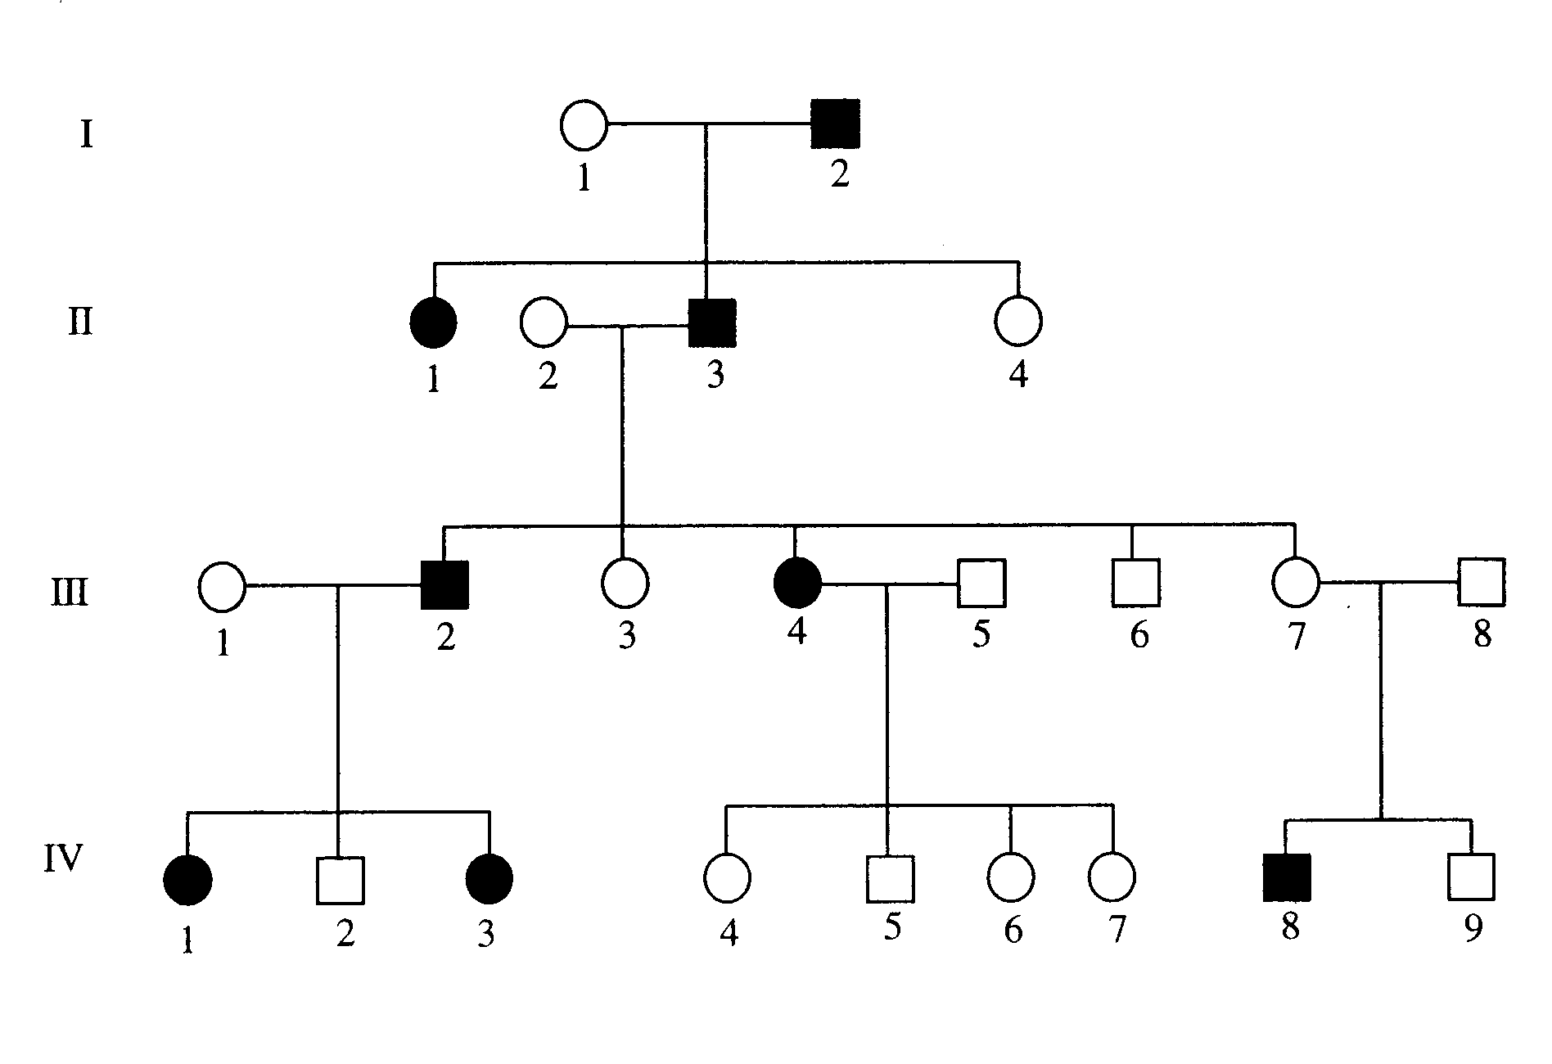

(a) How many people in total show the disorder in this family? (1 mark)

(b) How many of the people with the disorder are female?
(1 mark)

(c) How many children did person II 2 and II 3 have in total?
(1 mark)

3. Use the listed words to complete the sentences below. (10 marks)

two | chromosomes | diploid | dominant | errors
gametes | physical | meiosis | replicate | guanine

The of cells contains genes made of DNA.

Genes determine many characteristics
(e.g. eye colour).

Diploid human cells contain 23 chromosomal pairs. cells, however, contain only 23 chromosomes.

In a DNA molecule, the number of thymine and adenine bases are always the same, and the amount of cytosine and bases are always the same.

During cell division (mitosis) the DNA needs to to ensure the new cells have identical copies of the DNA.

In most instances the DNA is copied exactly during mitosis. In some cases,
occur and mutations result.

Gametes are formed by a type of cell division called .

The fertilised egg has a number of chromosomes.

X and Y are the sex chromosomes. Females have X chromosomes and males have an X and a Y chromosome.

Different forms of a gene are called alleles. Alleles can be or recessive.

4. Use the words listed below to complete the following sentences. (9 marks)

protostar | billion | Milky Way | giants
constellations | space | nebulae | expansion
fusion

Groups of stars form patterns that are called .

Our solar system is part of a large galaxy called the .

Clouds of dust and gas in interstellar space are called .

According to the Big Bang Theory, the universe is about 13.7 years old.

The first stage of the Big Bang involved the formation of time and . Space then underwent rapid .

Stars are formed when gravity causes gas and dust to come together and heat up.
Eventually a is formed and then finally a star.

Stars like our sun evolve into red before they explode.

Stars generate their energy by nuclear in which hydrogen changes to helium.

5. Choose the correct definition for the term in the first column of the table below. Write the correct letter in the second column. (6 marks)

TERM | CORRECT LETTER | DEFINITION
Black dwarf |  | A: Pattern formed by a group of stars.
Nova |  | B: Formed by the expansion of a star about  the size of our Sun.
Red giant |  | C: Remains of the death of a massive star.
Black hole |  | D: Small, dead star that emits no light.
Constellation |  | E: Final stage in the development of a star.
Protostar |  | F: Explosion of the outer layers of an  average-size star.

5. Write the following words into the correct space. (5 marks)

6. The following diagram shows the rock cycle (brown) and water cycle (blue). Write the words listed into the correct place. (6 marks)

